## I Can Win and Bring It On

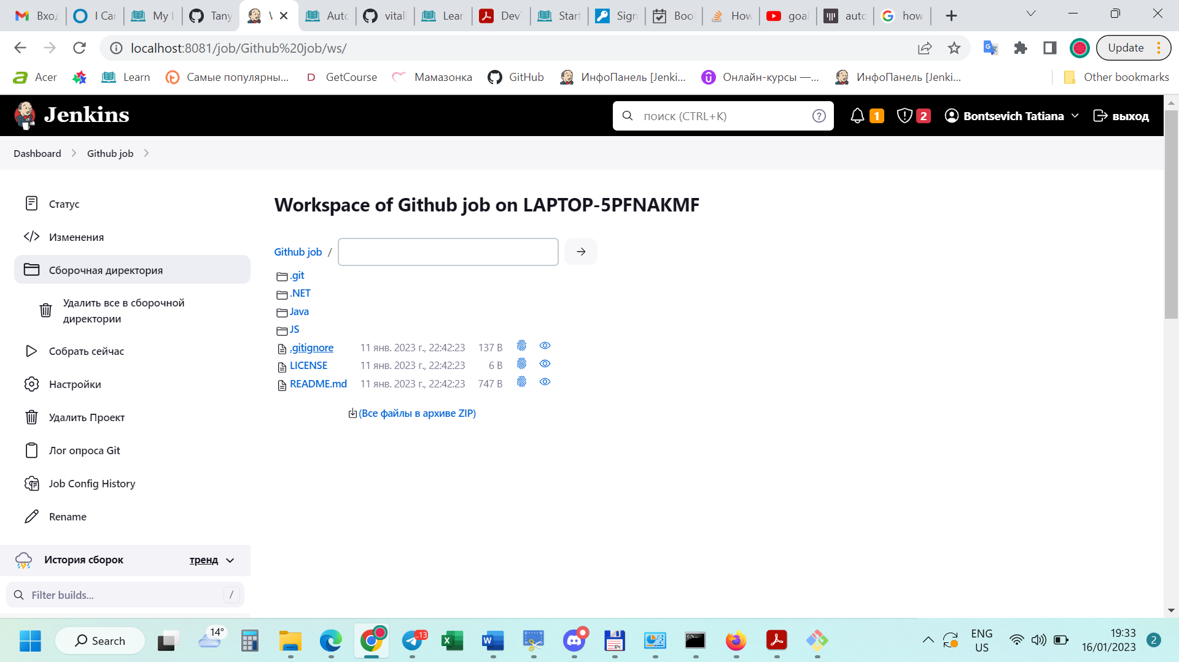

**Вывод на консоль**

Started by timer

Running as SYSTEM

Building remotely on [LAPTOP-5PFNAKMF](http://localhost:8081/computer/LAPTOP-5PFNAKMF) (chrome x64 Win 10) in workspace C:\Users\tanya\Slave\workspace\Github job

The recommended git tool is: NONE

No credentials specified

> c:\Program Files\Git\cmd\git.exe rev-parse --resolve-git-dir C:\Users\tanya\Slave\workspace\Github job\.git # timeout=10

Fetching changes from the remote Git repository

> c:\Program Files\Git\cmd\git.exe config remote.origin.url <https://github.com/vitalliuss/helloci.git> # timeout=10

Fetching upstream changes from <https://github.com/vitalliuss/helloci.git>

> c:\Program Files\Git\cmd\git.exe --version # timeout=10

> git --version # 'git version 2.39.0.windows.2'

> c:\Program Files\Git\cmd\git.exe fetch --tags --force --progress -- <https://github.com/vitalliuss/helloci.git> +refs/heads/*:refs/remotes/origin/* # timeout=10

> c:\Program Files\Git\cmd\git.exe rev-parse "refs/remotes/origin/master^{commit}" # timeout=10

Checking out Revision 71518a34152cb6c6039a2443ced60af30a31f14c (refs/remotes/origin/master)

> c:\Program Files\Git\cmd\git.exe config core.sparsecheckout # timeout=10

> c:\Program Files\Git\cmd\git.exe checkout -f 71518a34152cb6c6039a2443ced60af30a31f14c # timeout=10

Commit message: "Merge pull request #16 from EvgeniyRozhenko/fix-pom-utf8"

> c:\Program Files\Git\cmd\git.exe rev-list --no-walk 71518a34152cb6c6039a2443ced60af30a31f14c # timeout=10

[Github job] $ cmd.exe /C '""C:\Program Files\apache-maven-3.8.7\bin\mvn.cmd"' -f java/pom.xml test && exit %%ERRORLEVEL%%"

[INFO] Scanning for projects...

[INFO]

[INFO] ---------------< com.github.vitalliuss.helloci:hello-ci >---------------

[INFO] Building hello-ci 1.0-SNAPSHOT

[INFO] --------------------------------[ jar ]---------------------------------

[INFO]

[INFO] **--- maven-resources-plugin:2.6:resources (default-resources) @ hello-ci ---**

[INFO] Using 'UTF-8' encoding to copy filtered resources.

[INFO] skip non existing resourceDirectory C:\Users\tanya\Slave\workspace\Github job\java\src\main\resources

[INFO]

[INFO] **--- maven-compiler-plugin:3.1:compile (default-compile) @ hello-ci ---**

[INFO] Nothing to compile - all classes are up to date

[INFO]

[INFO] **--- maven-resources-plugin:2.6:testResources (default-testResources) @ hello-ci ---**

[INFO] Using 'UTF-8' encoding to copy filtered resources.

[INFO] skip non existing resourceDirectory C:\Users\tanya\Slave\workspace\Github job\java\src\test\resources

[INFO]

[INFO] **--- maven-compiler-plugin:3.1:testCompile (default-testCompile) @ hello-ci ---**

[INFO] Nothing to compile - all classes are up to date

[INFO]

[INFO] **--- maven-surefire-plugin:3.0.0-M1:test (default-test) @ hello-ci ---**

[INFO]

[INFO] -------------------------------------------------------

[INFO] T E S T S

[INFO] -------------------------------------------------------

[INFO] Running com.github.vitalliuss.helloci.AppTest

[ERROR] Tests run: 5, Failures: 1, Errors: 0, Skipped: 1, Time elapsed: 0.067 s <<< FAILURE! - in com.github.vitalliuss.helloci.AppTest

[ERROR] testShouldBeFailed(com.github.vitalliuss.helloci.AppTest) Time elapsed: 0.009 s <<< FAILURE!

java.lang.AssertionError

at com.github.vitalliuss.helloci.AppTest.testShouldBeFailed(AppTest.java:21)

[INFO]

[INFO] Results:

[INFO]

[ERROR] Failures:

[ERROR] AppTest.testShouldBeFailed:21

[INFO]

[ERROR] Tests run: 5, Failures: 1, Errors: 0, Skipped: 1

[INFO]

[INFO] ------------------------------------------------------------------------

[INFO] BUILD FAILURE

[INFO] ------------------------------------------------------------------------

[INFO] Total time: 4.256 s

[INFO] Finished at: 2023-01-16T13:01:34+03:00

[INFO] ------------------------------------------------------------------------

[ERROR] Failed to execute goal org.apache.maven.plugins:maven-surefire-plugin:3.0.0-M1:test (default-test) on project hello-ci: There are test failures.

[ERROR]

[ERROR] Please refer to C:\Users\tanya\Slave\workspace\Github job\java\target\surefire-reports for the individual test results.

[ERROR] Please refer to dump files (if any exist) [date].dump, [date]-jvmRun[N].dump and [date].dumpstream.

[ERROR] -> [Help 1]

[ERROR]

[ERROR] To see the full stack trace of the errors, re-run Maven with the -e switch.

[ERROR] Re-run Maven using the -X switch to enable full debug logging.

[ERROR]

[ERROR] For more information about the errors and possible solutions, please read the following articles:

[ERROR] [Help 1] <http://cwiki.apache.org/confluence/display/MAVEN/MojoFailureException>

Build step 'Invoke top-level Maven targets' marked build as failure

Archiving artifacts

Recording fingerprints

Finished: FAILURE

## Hurt Me Plenty

# Вывод на консоль

Started by user [Bontsevich Tatiana](http://localhost:8081/user/tanya_bonts)

Running as SYSTEM

Building remotely on [LAPTOP-5PFNAKMF](http://localhost:8081/computer/LAPTOP-5PFNAKMF) (chrome x64 Win 10) in workspace C:\Users\tanya\Slave\workspace\Github job

## Hardcore

# Вывод на консоль

Started by user [Bontsevich Tatiana](http://localhost:8081/user/tanya_bonts)

Running as SYSTEM

Building on the built-in node in workspace C:\Users\tanya\.jenkins\workspace\HelloUser

[WS-CLEANUP] Deleting project workspace...

[WS-CLEANUP] Deferred wipeout is used...

[WS-CLEANUP] Done

The recommended git tool is: NONE

No credentials specified

Cloning the remote Git repository

Cloning repository <https://github.com/vitalliuss/helloci.git>

> c:\Program Files\Git\cmd\git.exe init C:\Users\tanya\.jenkins\workspace\HelloUser # timeout=10

Fetching upstream changes from <https://github.com/vitalliuss/helloci.git>

> c:\Program Files\Git\cmd\git.exe --version # timeout=10

> git --version # 'git version 2.39.0.windows.2'

> c:\Program Files\Git\cmd\git.exe fetch --tags --force --progress -- <https://github.com/vitalliuss/helloci.git> +refs/heads/*:refs/remotes/origin/* # timeout=10

> c:\Program Files\Git\cmd\git.exe config remote.origin.url <https://github.com/vitalliuss/helloci.git> # timeout=10

> c:\Program Files\Git\cmd\git.exe config --add remote.origin.fetch +refs/heads/*:refs/remotes/origin/* # timeout=10

Avoid second fetch

> c:\Program Files\Git\cmd\git.exe rev-parse "refs/remotes/origin/master^{commit}" # timeout=10

Checking out Revision 71518a34152cb6c6039a2443ced60af30a31f14c (refs/remotes/origin/master)

> c:\Program Files\Git\cmd\git.exe config core.sparsecheckout # timeout=10

> c:\Program Files\Git\cmd\git.exe checkout -f 71518a34152cb6c6039a2443ced60af30a31f14c # timeout=10

Commit message: "Merge pull request #16 from EvgeniyRozhenko/fix-pom-utf8"

> c:\Program Files\Git\cmd\git.exe rev-list --no-walk 71518a34152cb6c6039a2443ced60af30a31f14c # timeout=10

[HelloUser] $ cmd /c call C:\Users\tanya\AppData\Local\Temp\jenkins2401776181658050326.bat

C:\Users\tanya\.jenkins\workspace\HelloUser>ECHO Hello, Tanya!

Hello, Tanya!

C:\Users\tanya\.jenkins\workspace\HelloUser>exit 0

[HelloUser] $ cmd.exe /C '""C:\Program Files\apache-maven-3.8.7\bin\mvn.cmd"' -f java/pom.xml cobertura:cobertura && exit %%ERRORLEVEL%%"

[INFO] Scanning for projects...

[INFO]

[INFO] ---------------< com.github.vitalliuss.helloci:hello-ci >---------------

[INFO] Building hello-ci 1.0-SNAPSHOT

[INFO] --------------------------------[ jar ]---------------------------------

[INFO]

[INFO] >>> cobertura-maven-plugin:2.7:cobertura (default-cli) > [cobertura]test @ hello-ci >>>

[INFO]

[INFO] **--- maven-resources-plugin:2.6:resources (default-resources) @ hello-ci ---**

[INFO] Using 'UTF-8' encoding to copy filtered resources.

[INFO] skip non existing resourceDirectory C:\Users\tanya\.jenkins\workspace\HelloUser\java\src\main\resources

[INFO]

[INFO] **--- maven-compiler-plugin:3.1:compile (default-compile) @ hello-ci ---**

[INFO] Changes detected - recompiling the module!

[INFO] Compiling 2 source files to C:\Users\tanya\.jenkins\workspace\HelloUser\java\target\classes

[INFO]

[INFO] **--- cobertura-maven-plugin:2.7:instrument (default-cli) @ hello-ci ---**

[INFO] ------------------------------------------------------------------------

[INFO] BUILD FAILURE

[INFO] ------------------------------------------------------------------------

[INFO] Total time: 1.250 s

[INFO] Finished at: 2023-01-14T21:23:34+03:00

[INFO] ------------------------------------------------------------------------

[ERROR] Failed to execute goal org.codehaus.mojo:cobertura-maven-plugin:2.7:instrument (default-cli) on project hello-ci: Execution default-cli of goal org.codehaus.mojo:cobertura-maven-plugin:2.7:instrument failed: Plugin org.codehaus.mojo:cobertura-maven-plugin:2.7 or one of its dependencies could not be resolved: Could not find artifact com.sun:tools:jar:0 at specified path C:\Program Files\Java\jdk-17.0.5/../lib/tools.jar -> [Help 1]

[ERROR]

[ERROR] To see the full stack trace of the errors, re-run Maven with the -e switch.

[ERROR] Re-run Maven using the -X switch to enable full debug logging.

[ERROR]

[ERROR] For more information about the errors and possible solutions, please read the following articles:

[ERROR] [Help 1] <http://cwiki.apache.org/confluence/display/MAVEN/PluginResolutionException>

Build step 'Invoke top-level Maven targets' marked build as failure

[Cobertura] Publishing Cobertura coverage report...

Finished: FAILURE